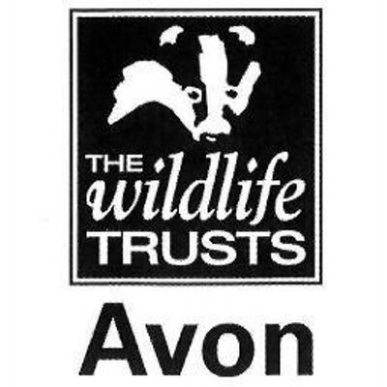

Wild Paths – new careers in nature conservation
Role Title:
Practical Conservation & Engagement Trainee
Based at:
Wiltshire Wildlife Trust - Lower Moor Nature Reserve, Oaksey, SN16 9TW
Mentor:
Ellie Jones – Reserves Field Officer North
Type of work the role will be involved with:
This placement will focus on WWT’s suite of reserve in the north of the county, with a base at our flagship reserve near Oaksey, Lower Moor. These reserves, many of which are designated as Sites of Special Scientific Interest, support a range of habitats, including unimproved flower-rich grassland, ancient woodland, lakes and wetlands. The trainee will also get the opportunity to work on other reserves in mid and South Wiltshire alongside reserves staff.

The trainee will gain experience of:
- Scrub clearance, tree felling, coppicing and hedgelaying
- Reserve infrastructure work and site maintenance, including fencing
- Livestock and grassland management
- Survey and monitoring
- Working with and leading volunteers from a wide range of backgrounds
- Community engagement, including guided walks and events
- Media and communication skills
- Health and safety, e.g. risk assessments

All trainees will receive training in key skill, such as time management, personal effectiveness, job application and interview techniques.

Skills and qualifications you can expect to gain in this role:
- Emergency First Aid at work Level 2
- Health and Safety at work
- NPTC CS30 & 31 Chainsaw maintenance, cross-cutting & small tree felling
- LANTRA Brushcutter
- Volunteer Management AQA accreditations
- AQA unit award scheme accreditations – options include:
  - Volunteer Management
  - Stock fencing
  - Wildflower identification
  - Woodland Management
  - Leading a group
  - Hedgelaying
  - Coppicing
  - Community engagement and inclusion
- 4x4 and quad bike familiarisation
- Species survey and identification skills
- Use of hand tools and appropriate power tools, e.g. mowers, drills
- Knowledge of basic ecological principles, habitat management techniques and relevant legislation

Disclosure and barring checks
A DBS check may be required for participation in certain activities.
Bursary:
£1000 per calendar month for nine months duration
Future progression
This role would provide the ideal background for progression into the conservation sector, working as an assistant warden or ranger.

