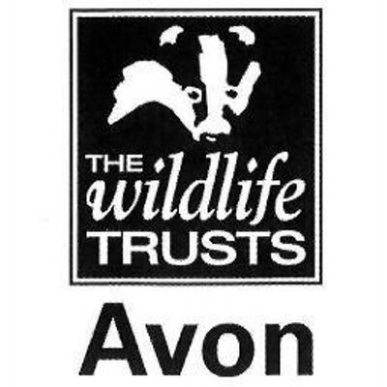

Wild Paths – new careers in nature conservation
Role Title:
Practical Conservation & Engagement Trainee
Based at:
Dorset Wildlife Trust – Kingcombe Meadows Farm, Toller Porcorum, West Dorset DT2 0EJ
Mentor:
Lucy Ferris – West Dorset Warden
Type of work the role will be involved with:
This placement is based at Kingcombe Meadows where the 180 ha nature reserve is managed as a traditional working farm, grazed by cows and sheep without the use of pesticides, artificial fertilisers and other modern agricultural practices. The result is a patchwork of fields of unimproved flower-rich grassland, broken up by thick hedges, streams, ponds, ancient green lanes & wooded areas spreading up the valley either side of the River Hooke and is almost entirely designated as a Site of Special Scientific Interest. The trainee will train at Kingcombe and at other West Dorset Reserves alongside reserves staff. The trainee will learn about:
- Scrub clearance, tree felling, coppicing and hedgelaying
- Fencing and reserve infrastructure work
- Stock management (cattle & sheep)
- Surveying and monitoring
- Working with and leading volunteers from a wide range of backgrounds
- Giving guidance and advice to the visiting public
- Community group engagement including guided walks and events
- Media and communications skills

All trainees will receive training in key skills such as time management, personal effectiveness, interview and application techniques.

Skills and qualifications you can expect to gain in this role:
- Emergency First Aid at work Level 2
- Health and Safety at work
- NPTC CS30 & 31 Chainsaw maintenance, cross-cutting & felling
- LANTRA Brushcutter
- Tractor or 4x4 driving
- Volunteer Management AQA accreditations
- AQA unit award scheme accreditations
  - Volunteer Management
  - Conservation grazing
  - Lookering
  - Woodland Management
  - Leading a group
  - Hedgelaying
  - Coppicing
  - Community engagement and inclusion
- Species identification skills
- Ability to use hand tools
- Habitat management and natural history knowledge

Disclosure and barring checks
This role is unlikely to require a DBS check
Bursary:
£1000 per calendar month for nine months duration
Future progression
This role would provide the ideal background for progression into the sector, working as an assistant warden or ranger, especially with a conservation grazing element.

